Special Winter HOT Food. $11.99

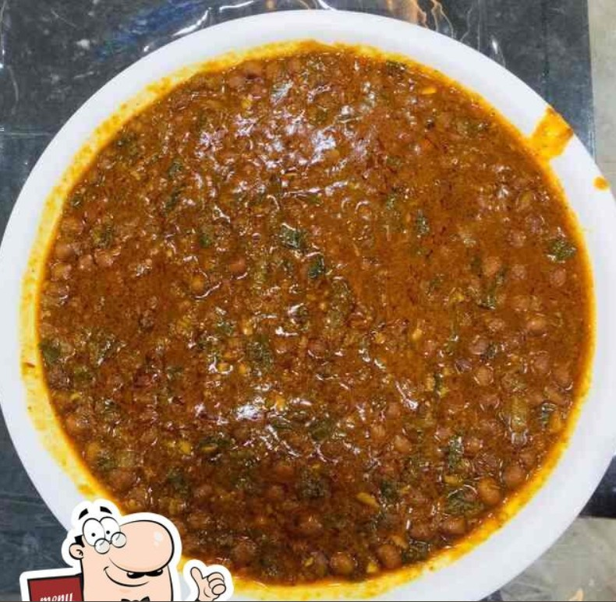

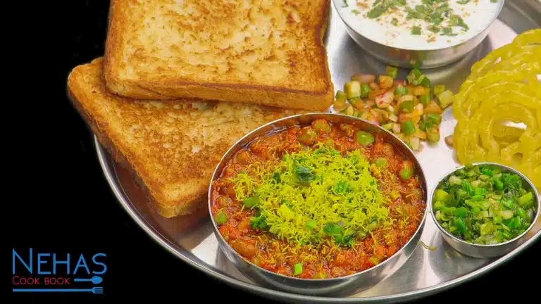

INGREDIENTS: Lots of Green Garlic, Ginger pest, Onion, Tomato, Green chili, Turmeric, Red Chili, Green Onion, Oil, Lemon, Pigeon pea, unrefined brown sugar, cluster seed, cumin seed, Musted seed, Hot Masala.

